**Lab 2**

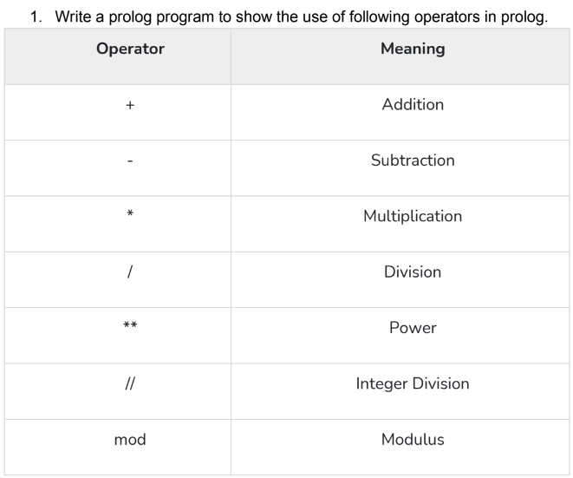

**Objective:**

The objective of this task is to write a Prolog program that

demonstrates the use of various operators to the console.

**Code:**

cal:- X is 100+10,write(X),nl,

Y is 100-10,write(Y),nl,

A is 100*10,write(A),nl,

B is 100/10,write(B),nl,

C is 100//10,write(C),nl,

D is 100 mod 10,write(D).

**Output:**

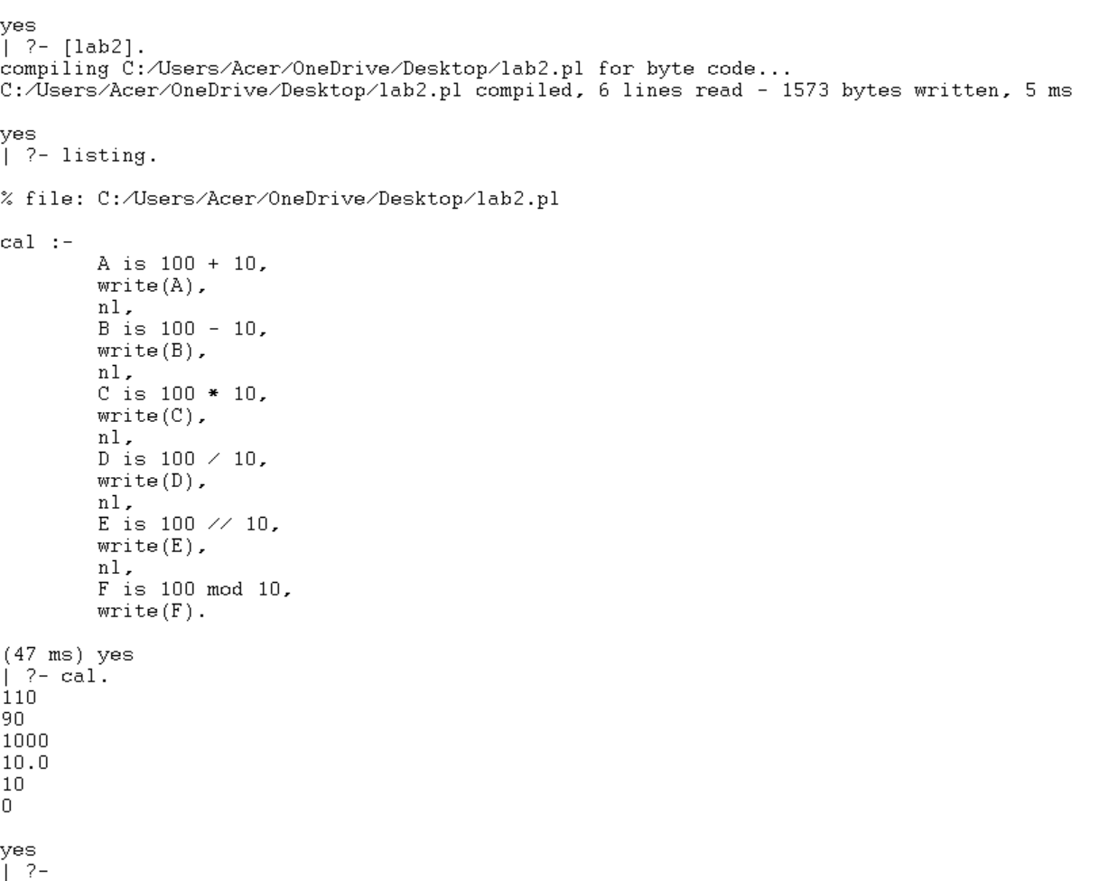

Task:

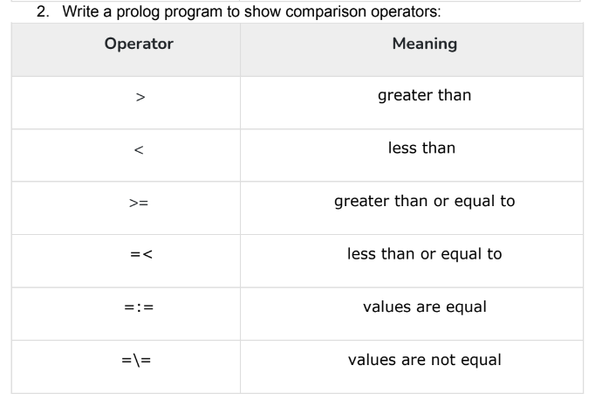

**Objective:**

The objective of the task typically involves demonstrating how comparison

operators work within the Prolog programming language.

**Code:**

gt(X,Y):- X>Y,write('X IS GREATER THAN Y').

gtt(X,Y):- X<Y,write('X IS LESS THAN Y').

gttt(X,Y):- X>=Y,write('X IS GREATER OR EQUAL TO Y').

gtttt(X,Y):- X=<Y,write('X IS LESS OR EQUAL TO Y').

gttttt(X,Y):- X=:=Y,write('X IS EQUAL TO Y').

gtttttt(X,Y):- X=\=Y,write('X IS NOT EQUAL TO Y').

**Output:**

